E-GOVERNMENT WEBSITE OF THE MUNICIPALITY OF
NOVELETA CAVITE

Stephen Ray C. Alvarez
Cyril R. Luna

An undergraduate project design outline proposal presented to the faculty of the Department of Information Technology, Cavite State University-Cavite City Campus, Cavite in partial fulfillment of the requirements for the degree of Bachelor of Science in Computer Science with Contribution No. ____________. Prepared under the supervision of Mrs. Teresita R. Tolentino.

INTRODUCTION

E-Government applications have emerged rapidly in the developing world. This is due to its usefulness as an enabling tool to increase efficiency and enhance transparency. Whilst various theories, processes, and models have been developed over time, there exists no structured methodology for the development of an e-Government environment.
E-Government is a concept that is increasingly accepted by practitioners and academicians in the information and communication technology environment. Government around the world are embracing e-Government from local, state and federal level, which explains its importance and fast spreading nature. Some of its benefits include enhancing transparency and increasing efficiency. E-Government is also essential for increasing revenue, promoting competitiveness and enhancing marketing in the public sector. As a result, numerous processes and applications have been developed over time, despite having no structured methodology.
Information and Communication Technology and the use of the Internet nowadays become an inevitable part of our economic, social life and development. The users of the Information and Communication Technology beyond household, individual and enterprises include governments as well. Although they only recently started using it, the government are using Information and Communication Technology in order to offer their services and to communicate with; citizens, among the employees of the organization itself, other government businesses. This is known nowadays as e-government. The main focus of e-government is to improve the delivery of government services; and to create a better government for citizens, business and other governments with the help of Information and Communication Technology and especially the internet.
In order to better understand e-government and what it offers, citizens need to know and have an understanding of traditional government services and e-government services. The main difference is that citizens are now able to have access to information, get documents, forms, and make a request through the internet instead of walking from one desk to another. E-government is also based on two-way communication with citizens, on websites where the citizens can find news, complaint, ask and find the answer to their questions. E-government has the aim of making government services more convenient, faster and more accessible to the citizens.
There is no current E-government that is applied in the Municipality of Noveleta so the researchers want to develop the E-government to improve the delivery of government services; and to create a better government for citizens, business and other governments.

Statement of the Problem
Specifically, the study seeks to answer the following problems:
- How to promote civic engagement by enabling the public to interact with government Officials and vice versa?
- How to have greater access to government information and activities?
- How to develop opportunities, especially the sorts that benefit rural and traditional underserved communities?
- How to have accountable and transparent governments in which the opportunities for corruption are reduced?
Objectives of the Study
The study generally aims to develop an E-Government website of the Municipality of Noveleta Cavite.
Specifically, it aims to:
- develop an e-government website of the Municipality of Noveleta;
- create the website using PhpStorm as website Integrated Development Environment, SQLyog as MySQL administration tools, Bootstrap 3 and Javascript as a framework for website’s responsiveness, and Adobe Photoshop as a graphic designing tool;
- test and improve the website; and
- evaluate the performance of the website based on ISO 25010.
Significance of the Study
The Municipality of Noveleta is currently using manual process in dealing and connecting to citizens using social media. It is too hard to advertise using Facebook because it can't view all the details of the service and to minimize the work and the time. It is important for the developer to determine the easiest way of advertising to the people.
The beneficiaries of this website are the other municipalities. With the help of this website, they can advertise more efficient and not time-consuming not like the manual process they're using before. Having a website is better than having a social media page because of its credibility. The citizens trust more if it has a website. With your own website, you have more leeway to communicate with your citizens.
This shall address the references of another upcoming web developer of the E-Government implemented website.
Time and Place of the Study
The study is being conducted at Municipality of Noveleta Cavite located in Magdiwang Hi-way, Noveleta, Cavite from May 2018 to May 2019.
Scope and Limitation of the Study
The study aims that e-government adoption from a supply-side perspective, which explores factors that affect the adoption and the implementation of e-government services by the government itself. These factors include IT infrastructure, financial resources, skilled personnel, resistance to change, and red tape.
This study generally focuses on the development of the website that will manage government information and e-services. The E-Government consists of Homepage, History of Noveleta, Our Government, Services, News, Downloads and Contact Us. The Homepage consists of Message from the Mayor, News, and Events, Value, Mission and Vision, Forms that can be downloaded and Numbers to call to in case of emergencies. The History of Noveleta consists of data about the history of the Town of Noveleta and the past events that happen in the said municipality that help the Filipinos to attain Independence. The Our Government consists of data about the Office of the Mayor, Profile of the Municipal Officials, Department, and Units of the Municipality and the Barangay Officials. The Services consists of online transactions that the website offers. The News consists of data about the current news and projects that the municipality offers. The Downloads consists of data and forms that the user can download and fill up so when he/she go to the Municipal Hall the transaction can be faster. The Contact Us consists of forms that let the viewer of the website to connect on the admin that maintain the website.
The website will not cater to payments via online, all monetary transaction will be done in the municipality premises.
Definition of Terms

This part of the study enumerates the terms used and how it is operationally defined to better understand this study.
E-Administration. It refers to any of a number of mechanisms which convert what in a traditional office are paper processes into electronic processes, with the goal being to create a paperless office.
E-Government. It is the use of electronic communications devices, computers, and the Internet to provide public services to citizens and other persons in a country or region.

E-Services. Are services which use of information and communication technologies (ICTs).
E-Society. It is a society that consists of one or more e-Communities involved in the areas from e-Government, e-Democracy, and e-Business to e-Learning and e-Health that use information and communication technologies (ICT) in order to achieve common interests and goals.
Information and communications technology. It is the term for information technology (IT) which stresses the role of unified communications and the integration of telecommunications, computers as well as necessary enterprise software, middleware, storage, and audio-visual systems, which enable users to access, store, transmit and manipulate information.
Conceptual Model of the Study
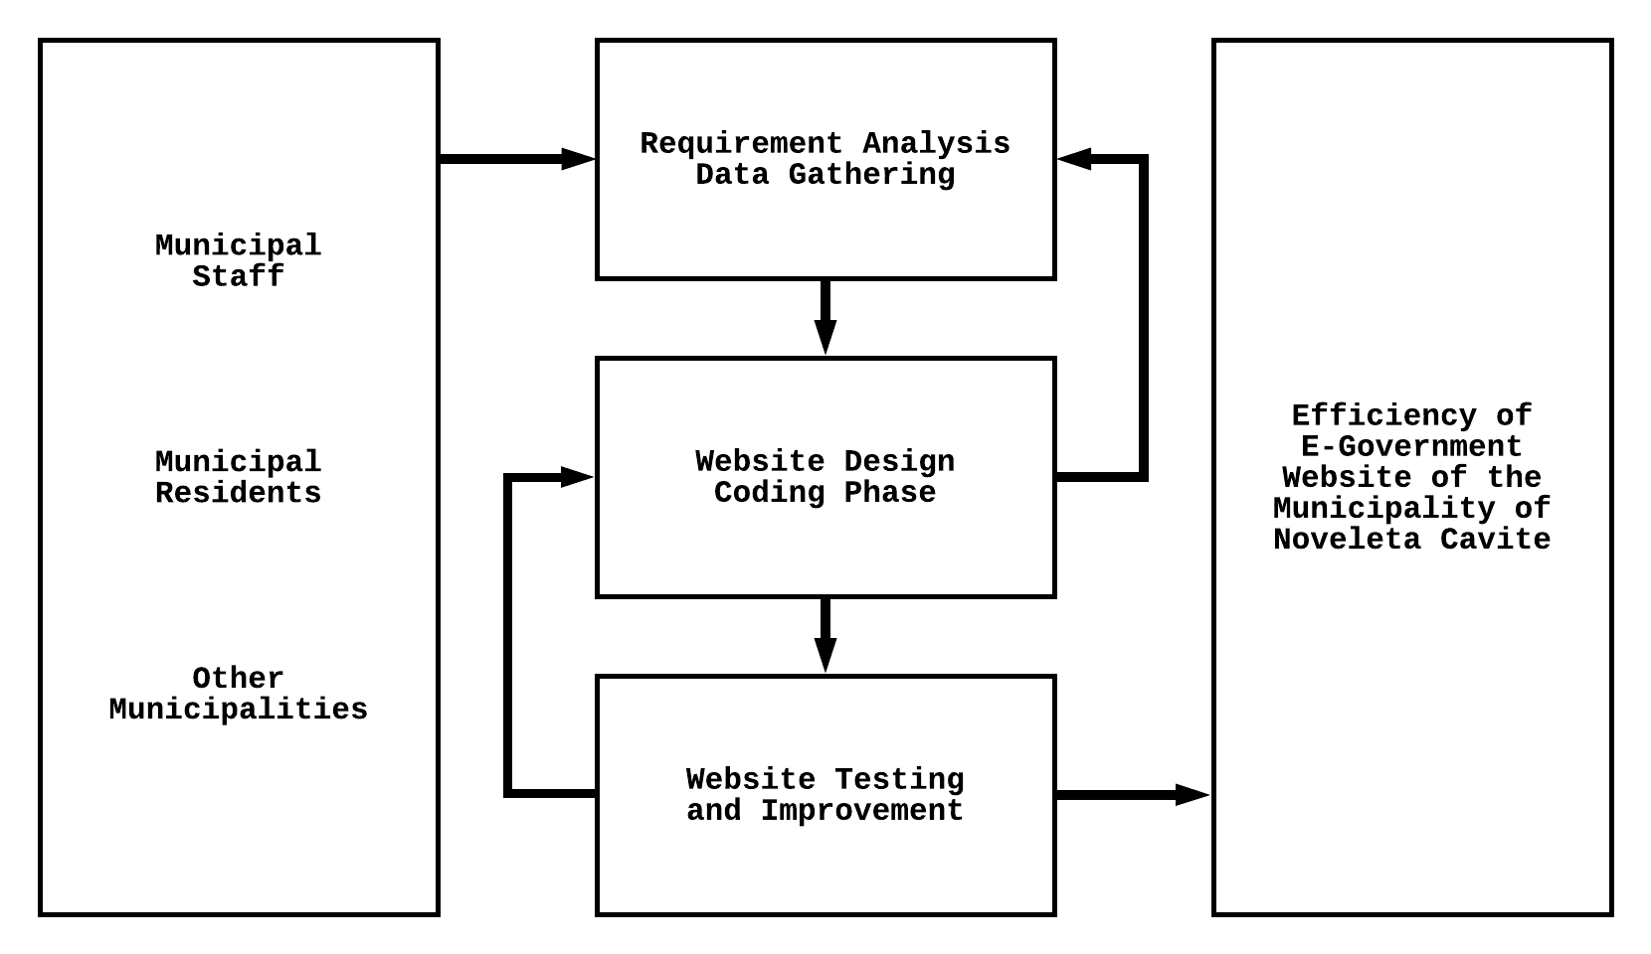
A conceptual transition is a model made up of the composition of concepts, which thus exists only in the mind. Conceptual model will be use to help the researchers know, understand, and simulate the subject matter presented on Figure No. 1.

Figure 1. Conceptual Framework of the E-Government Website of Municipality of Noveleta Cavite

